15.81: The tension in the rope will vary with radius r. The tension at a distance r from the center must supply the force to keep the mass of the rope that is further out than r accelerating inward. The mass of this piece in 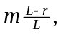and its center of mass moves in a circle of radius 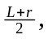and so

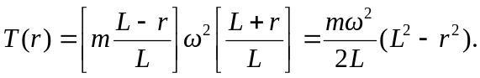
An equivalent method is to consider the net force on a piece of the rope with length dr and mass 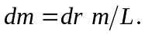 The tension must vary in such a way that This is integrated to obtained 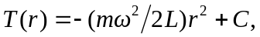 where C is a constant of integration. The tension must vanish at 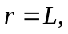from which 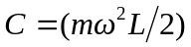and the previous result is obtained.

The speed of propagation as a function of distance is
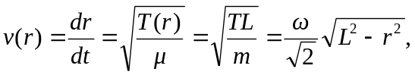
where 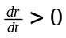 has been chosen for a wave traveling from the center to the edge. Separating variables and integrating, the time t is
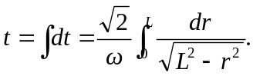
The integral may be found in a table, or in Appendix B. The integral is done explicitly by letting so that
